- Given simple graph G=(V,E), |V|=n and |E|=m, please prove that G is connected when m>(n-1)(n-2)/2.
- Can the following graph be drawn in one stroke ? Why ?
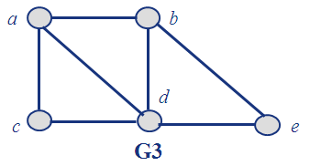

- Prove that K₅ and K_{3,3} are non-planar graphs.
- Prove that there are three persons who know each other or don’t know each other in every six persons in the world.
- Find out whether G and H are isomorphic. No matter what the judgment is, please give your explanation and argument.
